In this article we will be talking about installing Global Protect on an Mac computer.
For enlarged versions of the pictures below, click directly on the picture
(If you already have GlobalProtect installed proceed to step 10) here
- In the address bar type the address https://vpn.csufresno.edu.

- Select the global protect agent to install on your computer depending on your computer. For a Mac computers please download Mac 32/64 bit Global Protect agent.

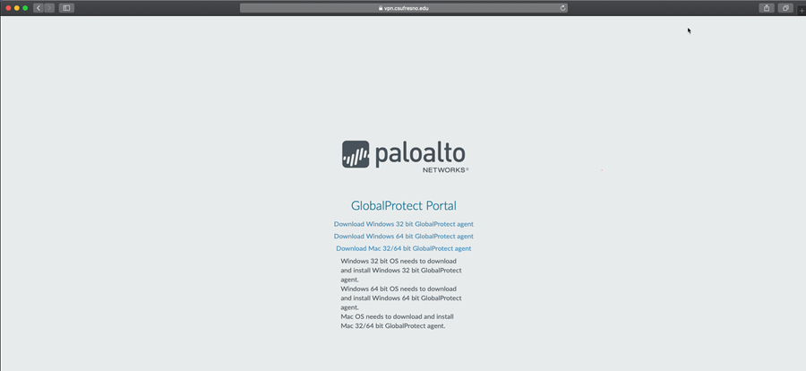

- Once you click the install again a Window will popup. Please click Allow on the new window.

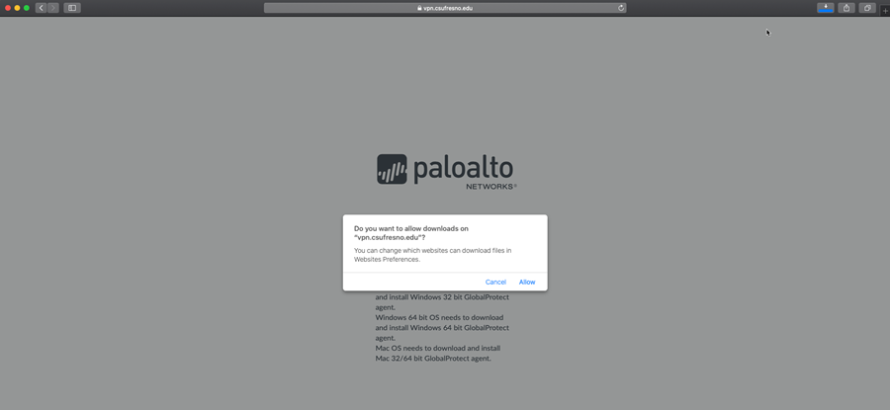

- After clicking allow download a new window will appear. In the new window please click Continue.
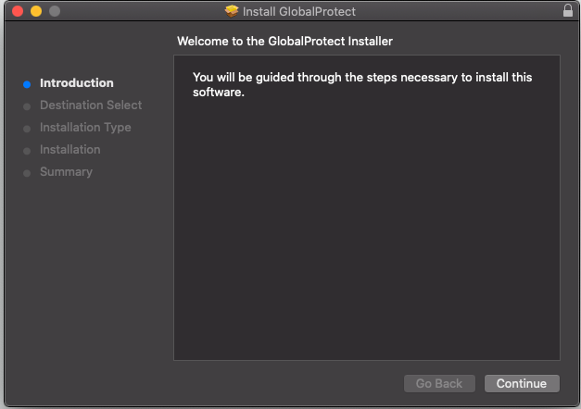

5. Next it will ask you where you want to install the program. The program will be installed on the “Macintosh HD” this should be the default selection. Next click Continue.

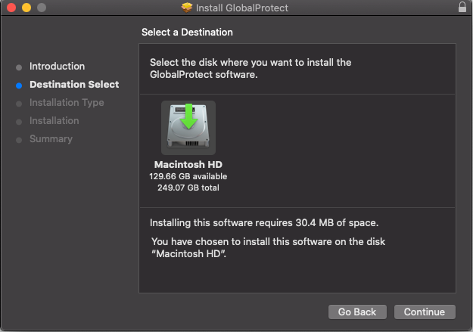

6. After downloading and uncompressing the install screen should pop up, Click continue. Please note that a window my popup asking for a password. This will be the password you use to log into your Mac computer.

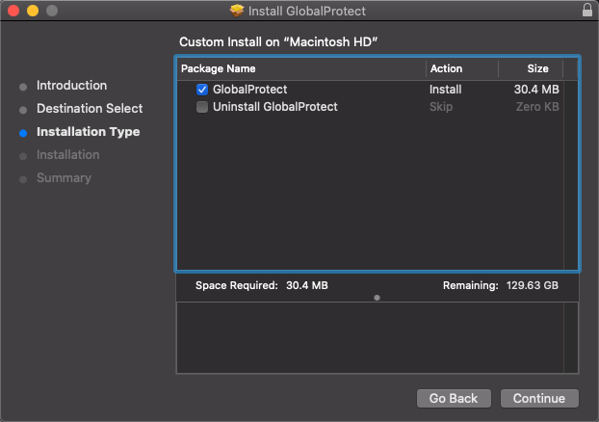

7. After Downloading and uncompressing the install application your computer will then ask you were you want to install the application. Again, please select “Macintosh HD”, this should be selected by default. Now click install.

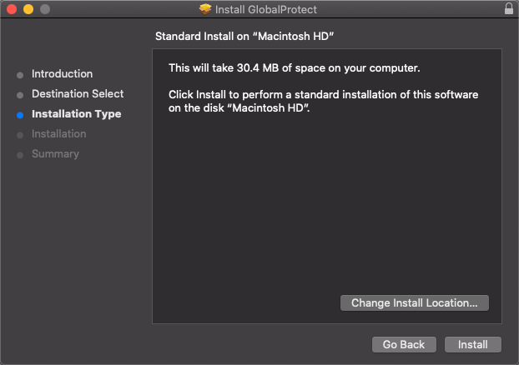

8. After clicking install a window will popup appear with your User Name. It will then ask you to type in your password. This password is the same password that you use to log into your Mac computer.

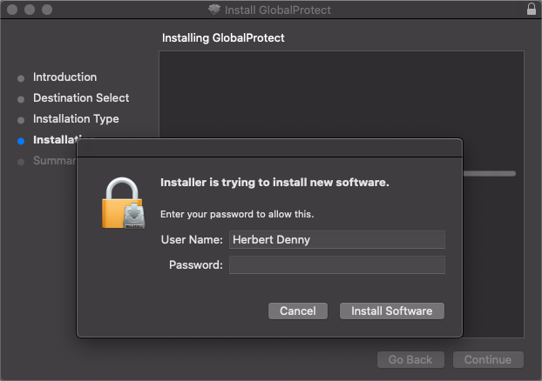

9. Once the application has installed you will see the image below. Please click on the close button.

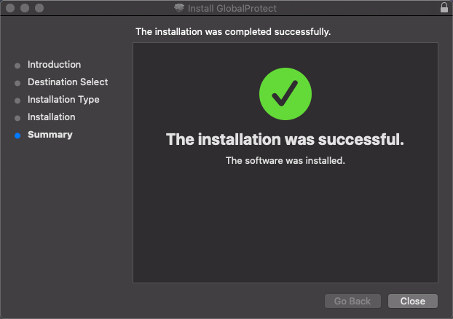

10. You have now installed Global Protect. To start up Global protect you will click on the world icon on your Mac mebu bar. In the Global Protect window enter the portal address vpn.csufresno.edu. (Click on any image below for an enlarged image)

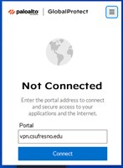
11. Click Connect and then you will see...

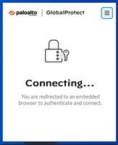

12. Click I agree to get into Campus Login Services

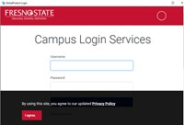

13. A sign in pop-up should appear prompting for usrename and password
Enter your computer login and password (same credentials used to log into your computer)
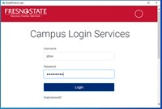
14. Use duo window to verify your identity
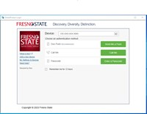

15. You should now be connected to VPN.
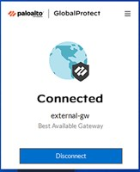
Again, please ensure you have a solid internet connection prior to attempting to connect to the VPN.
To disconnect, open the Global Protect app and click disconnect as shown above
....if you would like a hard copy of the above, click the following link

